WEEKLY STATUS REPORT
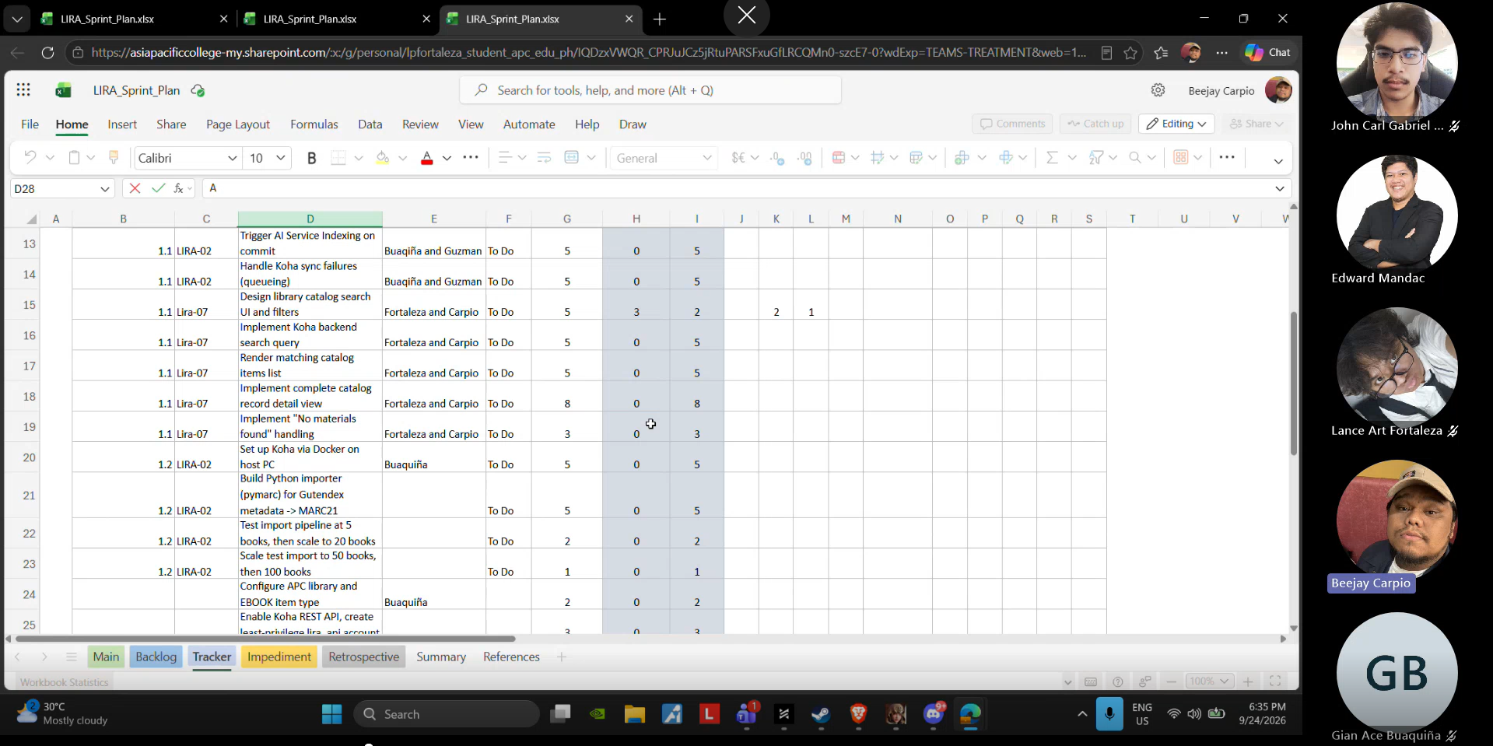
Date: 09-24-2026
Meeting Called By: Cache Flow
Facilitator: Sir Edward Mandac
Link of the Meeting: Cache Flow - Weekly Status Meeting-20260924_182805-Meeting Recording.mp4

Attendees
Gian Ace Buaquiña
Beejay A. Carpio
Lance Art P. Fortaleza
John Carl Gabriel Guzman

Agenda
- Review Sprint 1 updates and progress across technical components and documentation
- Establish rules for logging daily hours and organizing ad-hoc -tasks in the sprint tracker
- Clarify sprint cutoff dates, rollover tasks, and weekend work policies
- Review updated Use Case Diagrams and external system boundary definitions

Summary
Reviewed progress made during Sprint 1: configured Koha with sample data from Project Gutenberg, developed the View Library Catalog interface for students and faculty, and updated project diagrams and fully dressed use cases. Sir Edward provided guidelines on sprint tracker management, requiring all team members to log accumulated daily hours for assigned tasks and create an "Ad-Hoc Tasks" entry (up to 1 hour/day) for non-user-story activities like research, environment setups, and documentation. Clarified sprint operational boundaries with Sir Edward: Sprint 1 officially ends on Friday, September 25, 2026. Unfinished tasks will overflow into Sprint 2 during Monday's sprint planning session, and weekend activities will remain unrecorded on the formal sprint tracker. Reviewed the updated Use Case Diagram with Sir Edward, containing four core fully-dressed use cases (Managed Library Catalog, Managed Borrowed Books, Managed Chatbot, and Managed Reports), clarifying external interactions with systems like DocuPoles and Microsoft Entra ID.

Blockers/Obstacles encountered this week

